Les Voyages
Unscramble each of the clue words.
Copy the letters in the numbered cells to other cells with the same number.

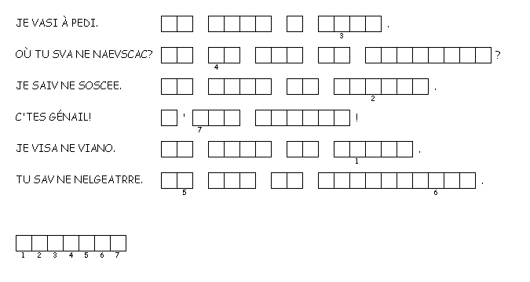
Use the grid below to create a wordsearch in French including modes of transport, countries and opinions. On the right-hand side, write in English the words that have to be found. One word has been completed as an example.

plane
a
v
i
o
n

